MOSFET circuits with Resistor(s) and DC source.
Fill in the blanks in the following table given the four circuit configurations below. Assume V_{T} = 1V and k = 1mA/V². In the Mode column enter one of the following:
- “Off” when V_{G}<V_{T},
- “Triode” when V_{DS} < V_{GS} - V_{T} or
- “Saturation” when V_{DS} >= V_{GS} - V_{T}.
When the MOSFET is in the triode mode put “??” in the I_{D} column and any column that depends on I_{D}. When the MOSFET is in off mode, put “??” in the I_{D} column and any column that depends on I_{D}.

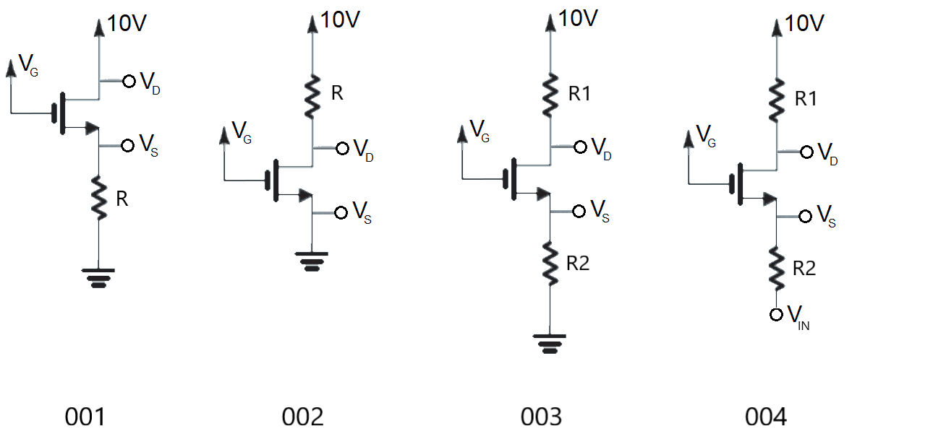

Circuit | V_{D} | V_{G} | V_{S} | V_{GS} | V_{OV} | R | I_{D} | Mode
001 |  | 0V |  |  |  | xx
001 |  | 3V |  |  |  | 1k
001 |  | 6V |  |  |  | 1k
001 |  | 3V |  |  |  | 10k
001 |  | 6V |  |  |  | 10k
001 |  | 3V |  |  |  | 100k

Circuit | V_{D} | V_{G} | V_{S} | V_{GS} | V_{OV} | R | I_{D} | Mode
002 |  | 0V |  |  |  | x
002 |  | 3V |  |  |  | 100Ω
002 |  | 3V |  |  |  | 1kΩ
002 |  | 3V |  |  |  | 10kΩ
002 |  | 6V |  |  |  | 100Ω
002 |  | 6V |  |  |  | 1kΩ

Circuit | V_{D} | V_{G} | V_{S} | V_{GS} | V_{OV} | R1 | R2 | I_{D} | Mode
003 |  | 0V |  |  |  | xx
003 |  | 3V |  |  |  | 1kΩ | 1k
003 |  | 6V |  |  |  | 1kΩ | 1k
003 |  | 3V |  |  |  | 10k | 10k
003 |  | 3V |  |  |  | 100k | 1k
003 |  | 6V |  |  |  | 10k | 1k

Let Vin = 3V
Circuit | V_{D} | V_{G} | V_{S} | V_{GS} | V_{OV} | R1 | R2 | I_{D} | Mode
004 |  | 6V |  |  |  | 1kΩ | 1kΩ

Practical Application - Half Bridge circuit with bootstrap capacitor

The following circuit allows a low power signal, modeled as the 3V, 100Hz square wave in the schematic, to control a high voltage, high power load, modeled as the 100Ω resistor. In order to understand how the following circuit accomplishes this, work through the following questions.
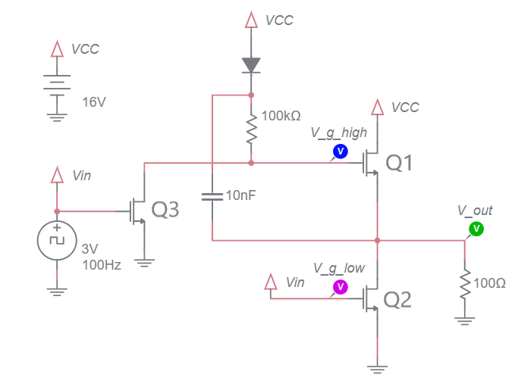
Assume that Vin is 3V
- Do MOSFETs Q2 and Q3 act more like open switches (allowing no current to flow) or closed switches (allowing current to flow)?
- Assume MOSFET Q3 is acting like a closed switch
  - What is the gate voltage of MOSFET Q1?
  - Can V_{gs} of Q1 ever be greater than V_{T}?
  - Does Q1 act like an open switch or closed switch?
The switch settings you have discovered are incorporated in the schematic to produce the modified schematic shown below left.
- After a short delay, what will be the voltage across the 10nF capacitor. For simplicity, assume an ideal diode model.
Assume that Vin is 0V
- Do MOSFETs Q2 and Q3 act more like open switches (allowing no current to flow) or closed switches (allowing current to flow)?
- Assume MOSFET Q3 is acting like an open switch and that the 10nF is fully charge from a period where Vin was 3V
  - What is V_{gs} for MOSFET Q1? Hint the answer is dictated by the voltage stored on the 10nF capacitor.
  - Does Q1 act like an open switch or closed switch?
The switch settings you have discovered are incorporated in the schematic to produce the modified schematic shown below right.
- The charge on the top plate of the capacitor flow could flow
  - Through the 100kΩ and on to the drain of Q3 to ground
  - Through the 100kΩ and on to the gate of Q1
  - Through the diode to Vcc
In each case, explain why no charge will flow off the top plate of the capacitor.
MOSFET behavior when Vin = 3V | MOSFET behavior when Vin = 0V

